**Final Project**

**DS 710**

The final project for this class is your opportunity to apply what you have learned in this course to answer a question that interests you, by collecting and analyzing real-world data from Twitter.

For your final project, you will submit

a) A **1-page** executive summary which reports your question, analysis, and results in a non-technical manner.

* It should include at least 1 figure, which may be embedded with the text or included on a second page.
* In .docx or .pdf format.

b) A Python notebook containing the Python code you used to gather data from Twitter and parse it for analysis.

* Do not include your consumer key, consumer secret, access token, or access secret.
* This should be a clean, commented, final version of the code.

c) A .csv or .txt file containing your parsed data for analysis in R.

d) An R script containing the R code you used to analyze the data from Python.

* This should be a clean, commented, final version of the code.
* It can be a .r file, or a .docx or .pdf file generated from R Markdown.
* R output from hypothesis tests should be included as comments.

Submit your project to GitHub.

A detailed checklist for the project is available on the next pages.

**Executive Summary (40 points)**

|  |  |
| --- | --- |
|  | **What to include** |
| **Length** | * Summary is one page (not including figures), with figures possibly pushing text onto a second page. |
| **Introduction** | * Clearly explains the question of interest, and why/to whom it is interesting. |
| **Data Collection and Analysis** | * Clearly explains what keywords/features used to collect data, and why these keywords/features are appropriate to address the question of interest. * States when data were collected, and whether the REST or Streaming APIs (or both) were used. * Method(s) of analysis are appropriate to the question of interest and explained in a non-technical way. * Includes at least 1 hypothesis test, and the conclusion is explained correctly and in a non-technical way. |
| **Figures** | * Includes at least 1 graph. (Note: You may include tables if appropriate, but tables are not graphs.) * Does **not** include R output from hypothesis tests. That’s too technical for an executive summary. * Figures are appropriate to the data and question of interest. * Well-integrated with discussion of analysis and/or results. (For example, “As shown in Figure 1, …”) * Legends or captions used appropriately. * Color used appropriately. * Font size and line widths chosen so that figures are legible when page is viewed at 100% Zoom. |
| **Results/Conclusion** | * Explains results clearly and accurately in a non-technical way. * Conclusion relates results to larger question or implications. |
| **Writing Style** | * Readable and interesting for a reader who does not know computer programming or statistics.   + You can refer to technical topics (for example, “Using a t-test, I found strong evidence that…”), but don’t get into the nitty-gritty here. * Professional spelling and grammar. |

**Parsed Data file (10 points)**

|  |  |
| --- | --- |
|  | **What to include** |
| **Parsed data file** | * Data file is in a .csv or .txt format. * Format of data file is consistent with Python code (no editing by hand was necessary). * Format is consistent with R code (no editing by hand is necessary to run R code for this data file). * Do a sanity check on your data. If you say you searched for tweets containing the phrase “data science”, there should not be any tweets with the word “data” but no “science.” |

**Python and R Code (50 points)**

|  |  |
| --- | --- |
|  | **What to include** |
| **Python and R Code** | * Code is consistent with analyses described in the executive summary. * Clean, final version of code: When run by the reader, code produces no error messages, and all output is relevant to the analysis in the executive summary. * Evidence of complex thinking or problem-solving in both Python and R. * Functions created for effective task management AND/OR evidence of effort put into writing efficient code. * Comments used appropriately to make code readable. * R output from hypothesis test(s) is included as comments in the R code. * DOES NOT include consumer key, consumer secret, access token, or access secret. |

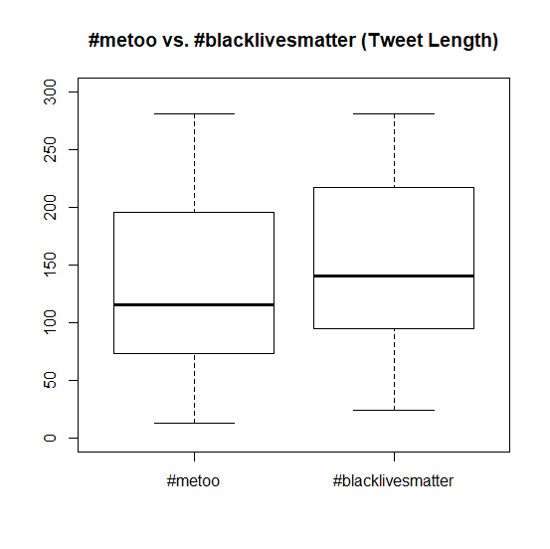

**Engagement = Favorites + Retweets**

t = 0.45761, df = 1652.7, p-value = 0.6473

mean of metoo mean of blm

8.371269 7.305793

**Tweet Length**

t = -5.8406, df = 2122.8, p-value = 6.004e-09

mean of metoo mean of blm

135.4543 154.0798

**Sentiment**

t = 7.292, df = 2113.2, p-value = 4.297e-13

mean of #metoo mean of blm

0.10296882 0.01684822

**Passion (Capital Letters + Exclamation Points + Question Marks)**

t = -6.5641, df = 2051.5, p-value = 6.611e-11

-5.301897 -2.862624

mean of metoo mean of blm

11.03265 15.11491

